DIS-Asia-Indus-Zebu Bull 2

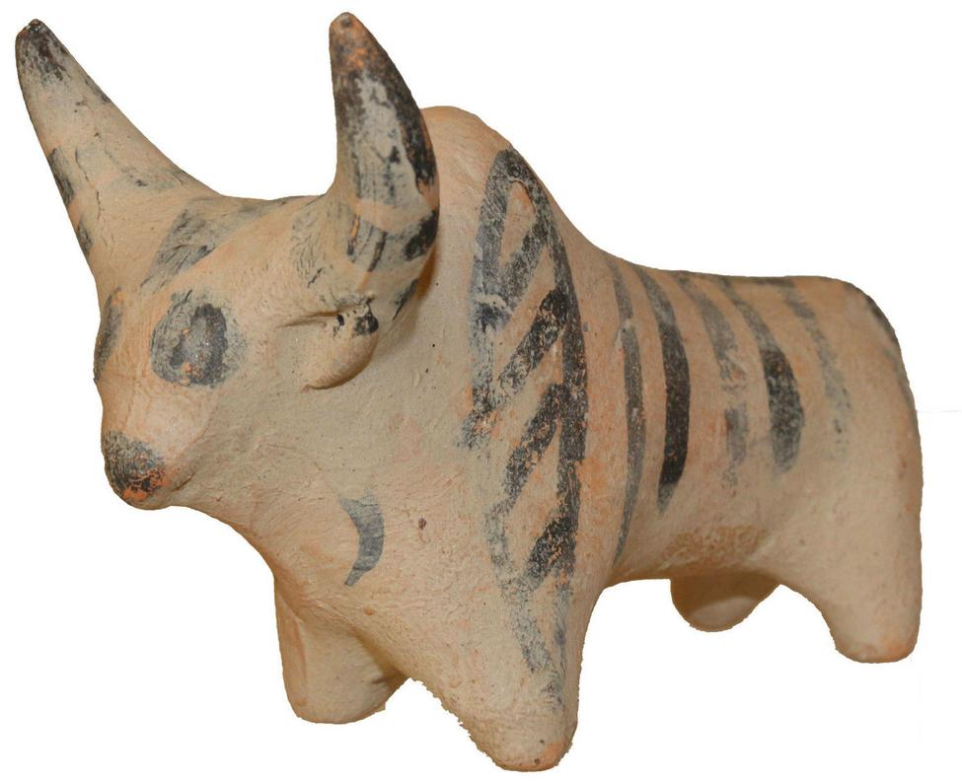

Culture:**Indus Valley (perhaps Mohenjo-Daro) Note striped lozenge marking on front shoulder.**

Date:**2400-2000 B.C.**

Medium:**Terracotta**

Condition: **Intact**

Provenance:**Ex: Important American private collection, 1970's**

Price: US $990.00

# Weight: 96gm., Size : 93mm x 69mm x 47mm

S Nicolaides

Alexandrou Papadiamandi

7020 CYPRUS default, Larnaca

Cyprus

Sold by [coinauction12](http://myworld.ebay.com/coinauction12) ( [5721](http://feedback.ebay.com/ws/eBayISAPI.dll?ViewFeedback&userid=coinauction12) )

### Delivery package 1 of 1

No estimate available

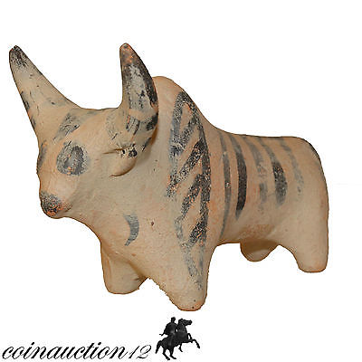

#### [NICE INDUS VALLEY TERRACOTTA BULL STATUE 500 BC](http://www.ebay.com/itm/201563708794)

|  |  |
| --- | --- |
| Item price | GBP 55.00 |
| Quantity | 1 |
| Item number | 201563708794 |
| Shipping service | Royal Mail International Signed |

## Sales order

Sold by [mikes-artefacts](http://myworld.ebay.com/mikes-artefacts) ( [878](http://feedback.ebay.com/ws/eBayISAPI.dll?ViewFeedback&userid=mikes-artefacts) )

### Delivery package 1 of 1

No estimate available

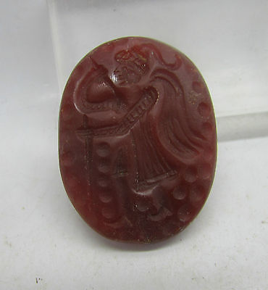

#### [Nice ancient Sassanian carnelian cameo C. 600AD](http://www.ebay.com/itm/152065171403)

|  |  |
| --- | --- |
| Item price | GBP 60.00 |
| Quantity | 1 |
| Item number | 152065171403 |
| Shipping service | Royal Mail International Tracked |

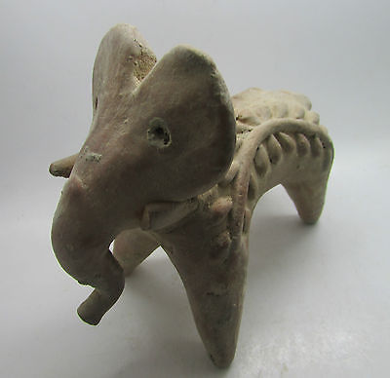

#### [Nice ancient Indus valley terracotta elephant figurine C. 2200-1800BC](http://www.ebay.com/itm/152065496473)

|  |  |
| --- | --- |
| Item price | GBP 70.00 |
| Quantity | 1 |
| Item number | 152065496473 |
| Shipping service | Royal Mail International Tracked |

## Shipping address

Ralph J Coffman Jr

149 Atlantic Ave

Swampscott MA 01907-2427

United States

## Order total

|  |  |
| --- | --- |
| Subtotal | GBP 185.00 |
| Shipping | GBP 9.99 |

**Total**

GBP 194.99

Order placed on

Sunday, Apr 24, 2016

Payment method

PayPal

Payment date

Sunday, Apr 24, 2016